OCEANA COUNTY
JUNIOR MARKET
POULTRY RECORD BOOK - 2025
(for ages 5-7)

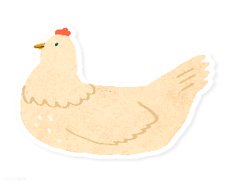

As a member of the Junior Market Animal Project, you are required to submit your records as part of an educational project notebook in order to show your animal at the Oceana County Fair. This notebook must be shown to the Poultry Superintendent or designated Small Market Weighmaster at the time of weigh-in and then entered by you in the Educational Notebook Division at the Oceana County Fair on Entry Day.

IF YOU ARE A LITTLE BUDDY PLEASE CHECK HERE: _____

My big buddy is: _________________________________________

NUMBER OF YEARS IN PROJECT: __________

AGE: __________
Your age you enter depends on how old you were on January 1, 2025.

Use this sheet as the first page of your project record book. Fill it out completely.

Please print or type neatly.

NAME ____________________________________________________________________________

4-H CLUB _________________________________________________________________________

LEADER __________________________________________________________________________

DATE RECORDS STARTED ___________________ DATE ENDED ____________________

JUDGE’S SCORE/COMMENT SHEET

(PLEASE DO NOT REMOVE, PLACE THIS SHEET IN SHEET PROTECTOR OR GLUE TO COVER). This sheet must be keep free to the judge to write their comments.

This sheet should help each junior market member understand their ribbon placing.

A. Specific educational value or worth

___ All questions were answered completely

___ All calculations were correct

___ Calculations were incorrect

___ Questions were not completely answered

___ Questions were not answered (missed questions)

B. Notebook contains all project records

___ Notebook contained all project records and were fully completed

___ Notebook contained additional project related information (research

materials etc.)

___ Project records were incomplete

___There was no additional project related information

C. Accuracy, neatness and general appearance

___Notebook was neat in appearance (typed/hand printed)

___ Notebook pages were clean and stain free

___Notebook pages were in order and complete

___Notebook pages were out of order and missing pages

___Notebook was difficult to read and messy

___Notebook had wrinkled and stained pages

Other Comments:

__________________________________________________________________________________________

__________________________________________________________________________________________

______________________________________________________________________
2025-JUNIOR MARKET POULTRY PAGE 2

OBJECTIVES
- Develop desirable work habits, sportsmanship, and ability to cooperate and express ideas through participation in projects, discussions, method demonstrations, judging teams, and exhibits.
- Experience the pride and responsibility of leasing/owning and caring for poultry.
- Learn how to feed, fit, show, breed and raise poultry.
- Learn proper handling procedures to prevent injuries to members and their poultry projects.
- Appreciate and use scientific information in poultry production and marketing.
- Improve knowledge of grading, marketing and merchandising of poultry and poultry products.
- Improve knowledge of the nutritive value of poultry meat and eggs and how they contribute toward good health.
- Learn the importance of the poultry industry to the local, state, and national economies.
- Acquire information on the opportunity that poultry offers as a career.
This record book is part of your Junior Market Poultry project. By keeping records up-to-date you will be able to see how much progress you make as you set goals and work to accomplish them. Write or type neatly and clearly. Please keep the pages in order. Feel free to add extra pages at the end of your notebook. Pictures are a required part of your notebook. Taking pictures of your animal project throughout the project will indicate how your animal has grown and developed. Add pictures to your notebook on a separate piece of paper.

SCORING CRITERIA
The following breakdown will be used during the judging process of all market livestock notebooks.

A. Specific educational value or worth 30%
B. Creative way of showing what has been learned 10%
C. Notebooks contain all project records 50%
D. Accuracy, neatness and general appearance 10%

The Oceana County Agricultural Society encourages parent assistance with your project and project notebook.

If a parent or adult helped you in filling out your notebook, please have them sign below that the answers are YOUR answers and that they assisted you in writing of the answers and understanding of the questions only.

________________________________________________________________________________
(Signature of person helping with notebook)

________________________________________________________________________________________
(Printed name by member)
2025-JUNIOR MARKET POULTRY PAGE 3

ABOUT YOUR POULTRY

My Project’s Names are: (if you did not name your market projects, what is the name of your showmanship animal)

________________________________________________________________________

My Poultry’s breeds are: ______________________________________________

What color are your Poultry? _________________________________________

My Poultry favorite thing to do is: ___________________________________

________________________________________________________________________

WEIGHT CHART

Date | Age | Weight

FINAL WEIGHT (FW)___________ AGE__________ DATE___________

2025-JUNIOR MARKET POULTRY PAGE 4

EXPENSES

(A) Cost of project (chicks, ducklings, etc..) $_______________________

DATE | LBS. OF FEED | FEED TYPE/VARIETY | COST
 |  |  | $
(B) |  | TOTAL SPENT ON FEED | $

DATE | OTHER EXPENSES, VET, SUPPLIES, HOUSING, ETC. | COST
 |  | $
(C) | TOTAL SPENT ON OTHER EXPENSES | $

GRAND TOTAL OF ALL EXPENSES (TE): $ _______________________
(total of A, B and C)

_______________ ÷ _________________ = __________________________________________
Total Expenses (TE) + Final Weight (FW) Break Even Price (BE)
(or total cost per pound to raise your animal)

** have your parent, leader or an older teen in your club help you figure out your breakeven price. The breakeven price is the price that you need to get at the
Junior Market animal auction in order to not lose money on your market project. **

2025-JUNIOR MARKET POULTRY PAGE 5

ANIMAL CARE AND MANAGEMENT- JOURNAL OF CARE

Your project requires regular care and management.
Include the following:
- Feeding and watering practices
- Health practices and medicines (vaccinations, etc.)
- General Management (building a cage, cleaning living area, feed pans, etc.)

Daily- Things done once or twice a day
Weekly- Things done once or twice a week
Monthly- Things done once a month
Yearly- Things done one time or occasionally throughout the year
2025 JUNIOR MARKET POULTRY PAGE 6

Fill out the page that goes with your poultry project.
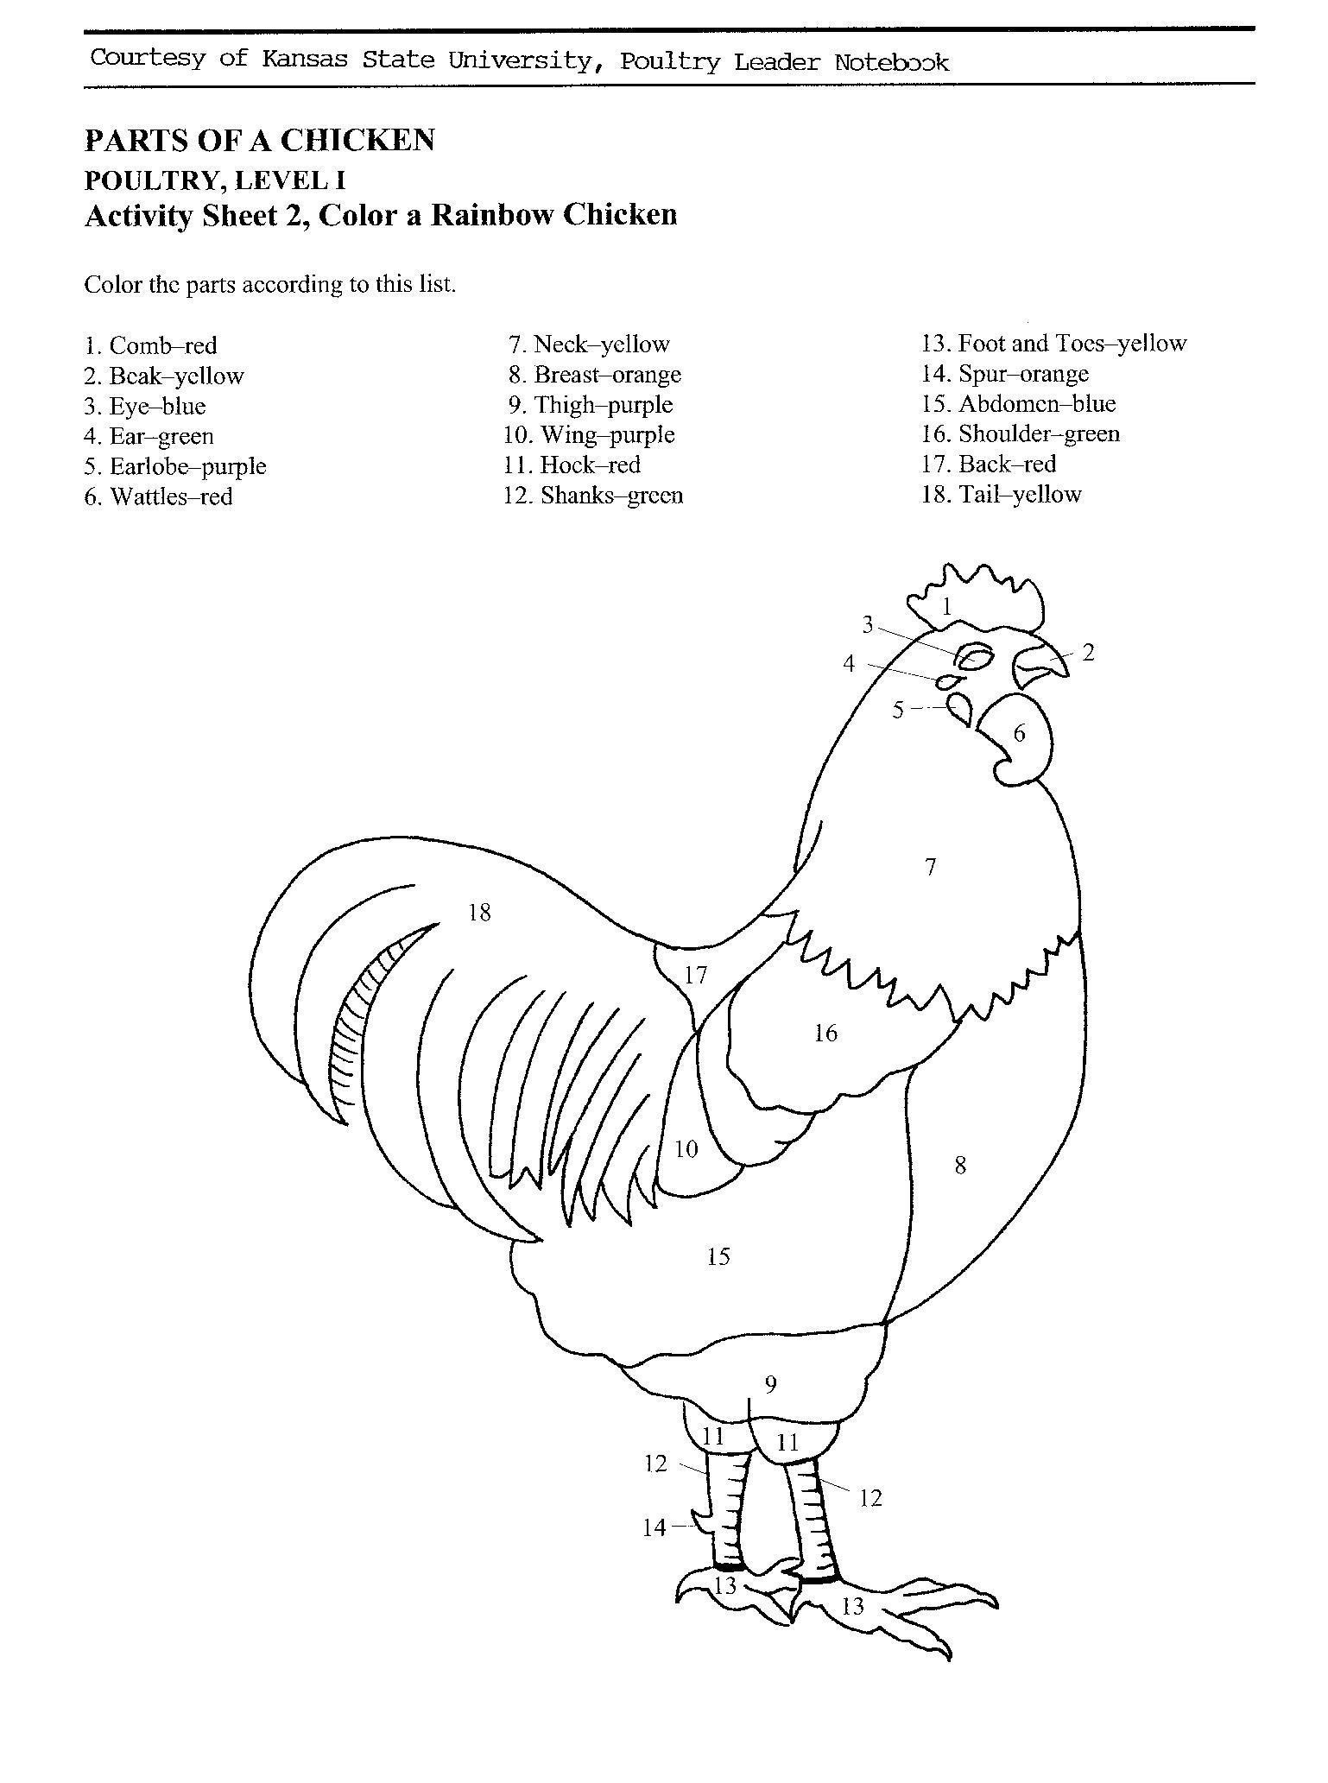

2025-JUNIOR MARKET POULTRY PAGE 7

Fill out the page that goes with your poultry project.

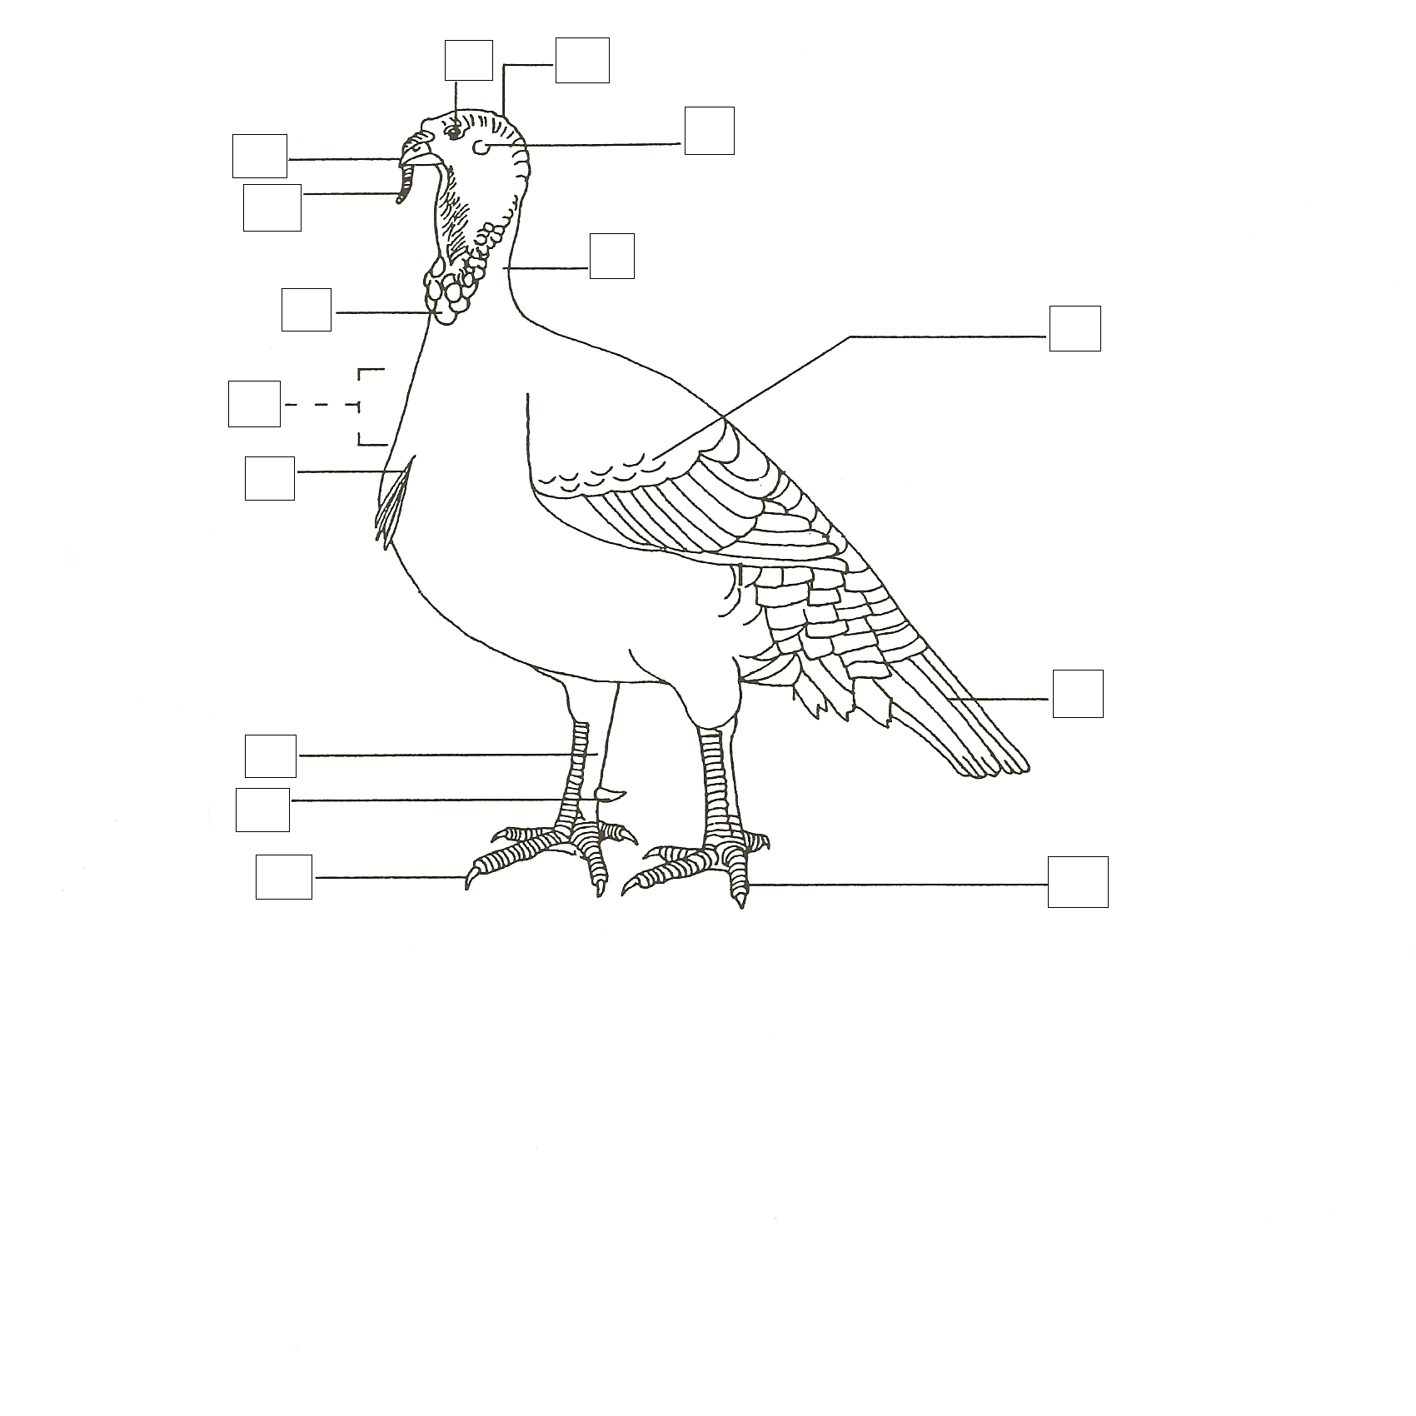
IDENTIFY THE PARTS OF THE TURKEY
(fill in the boxes in the above picture with
the letter corresponding to the correct part)

A. BEAK F. SHANK K. CARUNCLE
B. BEARD G. CROP AREA L. CROWN
C. COVERTS H. TOE M. NECK
D. TOENAIL I. EAR N. SNOOD
E. TAIL FEATHERS J. EYE O. SPUR

2025-JUNIOR MARKET POULTRY PAGE 8

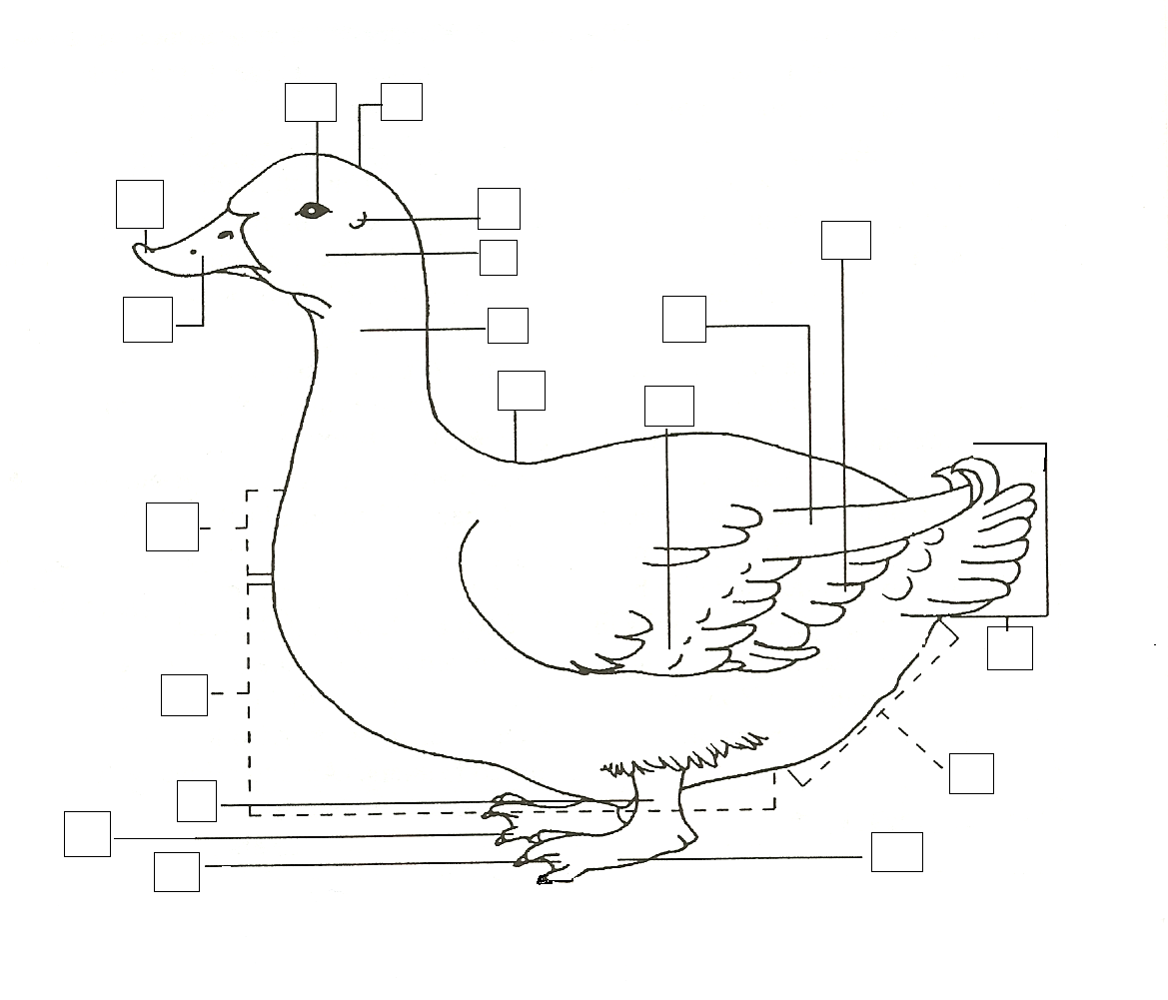
Fill out the page that goes with your poultry project.

IDENTIFY THE PARTS OF A DUCK
(fill in the boxes in the above picture with the letter corresponding to the correct part)

A. EYE K. SHANK
B. NECK L. ABDOMINAL AREA
C. SECONDARY WING FEATHERS M. FOOT
D. COVERTS N. CROWN
E. WEB O. EAR
F. CROP AREA P. BACK
G. BEAN Q. CHEEK
H. TAIL R. BILL
I. PRIMARY WING FEATHERS S. BREAST AREA
J. TOE

J. TOE

2025-JUNIOR MARKET POULTRY PAGE 9

Fill out the page that goes with your poultry project.
COLOR THE PARTS OF THE GOOSE:

BILL- YELLOW WING- BROWN CROP- BLUE
EYE- GREEN SHANK- BLACK BREAST- RED
TAIL- ORANGE FOOT- PURPLE

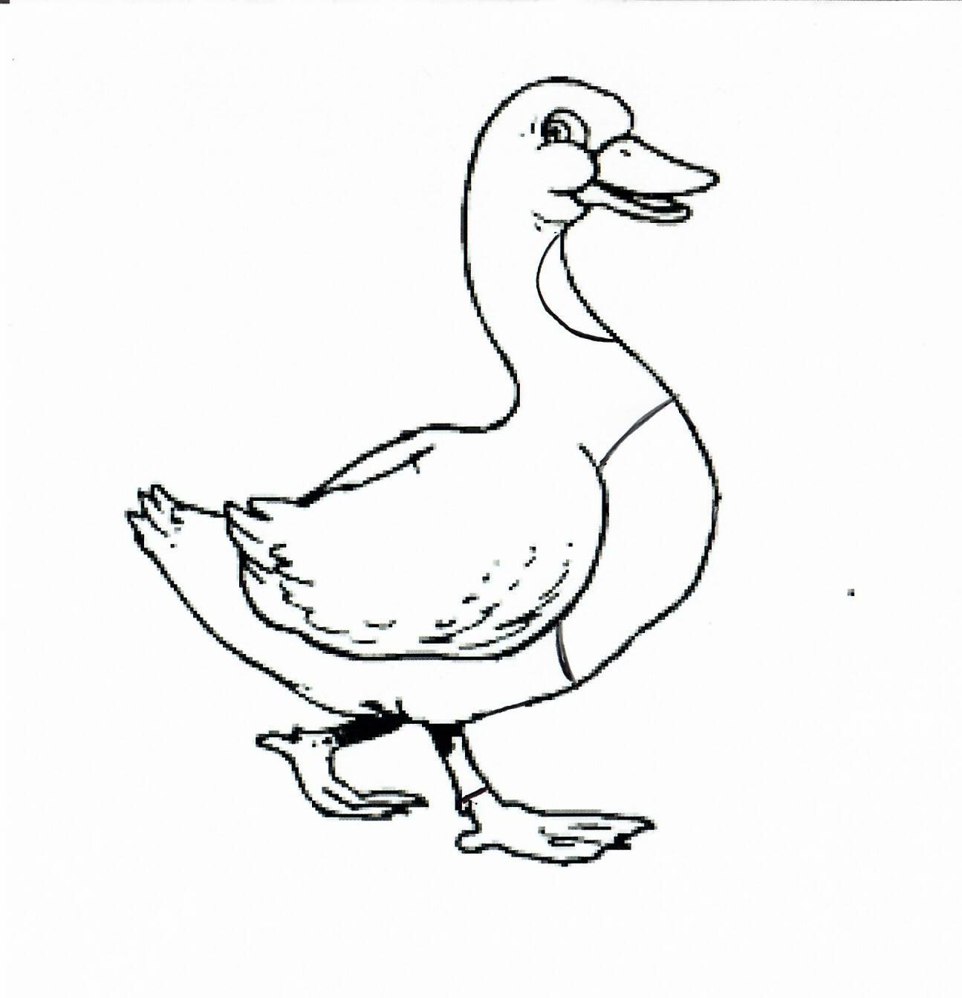
2025 JUNIOR MARKET POULTRY PAGE 10
Page 8
SMA Chickens
HATCH
PULLET
VENT
SCALES
COOP
HEN
ROASTER
PUREBRED
EMBRYO
ROOSTER
MOLT
SHANK

Finish the Sentences

1. My flock always needs clean, fresh __________________________________ to drink.

2. When I grow up I want to be a _________________________________________________.

3. The best, or most fun, part of my project was: __________________________________

_______________________________________________________________________________

_______________________________________________________________________________

______________________________________________________________________________

_______________________________________________________________________________

4. The hardest part of my project was: ____________________________________________

_______________________________________________________________________________

_______________________________________________________________________________

_______________________________________________________________________________

_______________________________________________________________________________

How did you show good character this year? Did you help someone, or maybe you treated your animals extra special?

__________________________________________________________________________________________

__________________________________________________________________________________________

__________________________________________________________________________________________

2025-JUNIOR MARKET POULTRY PAGE 11

Complete the page that goes with your project.

LEARN THE LIFE CYCLE OF A CHICKEN AS YOU COLOR THE PICTURE
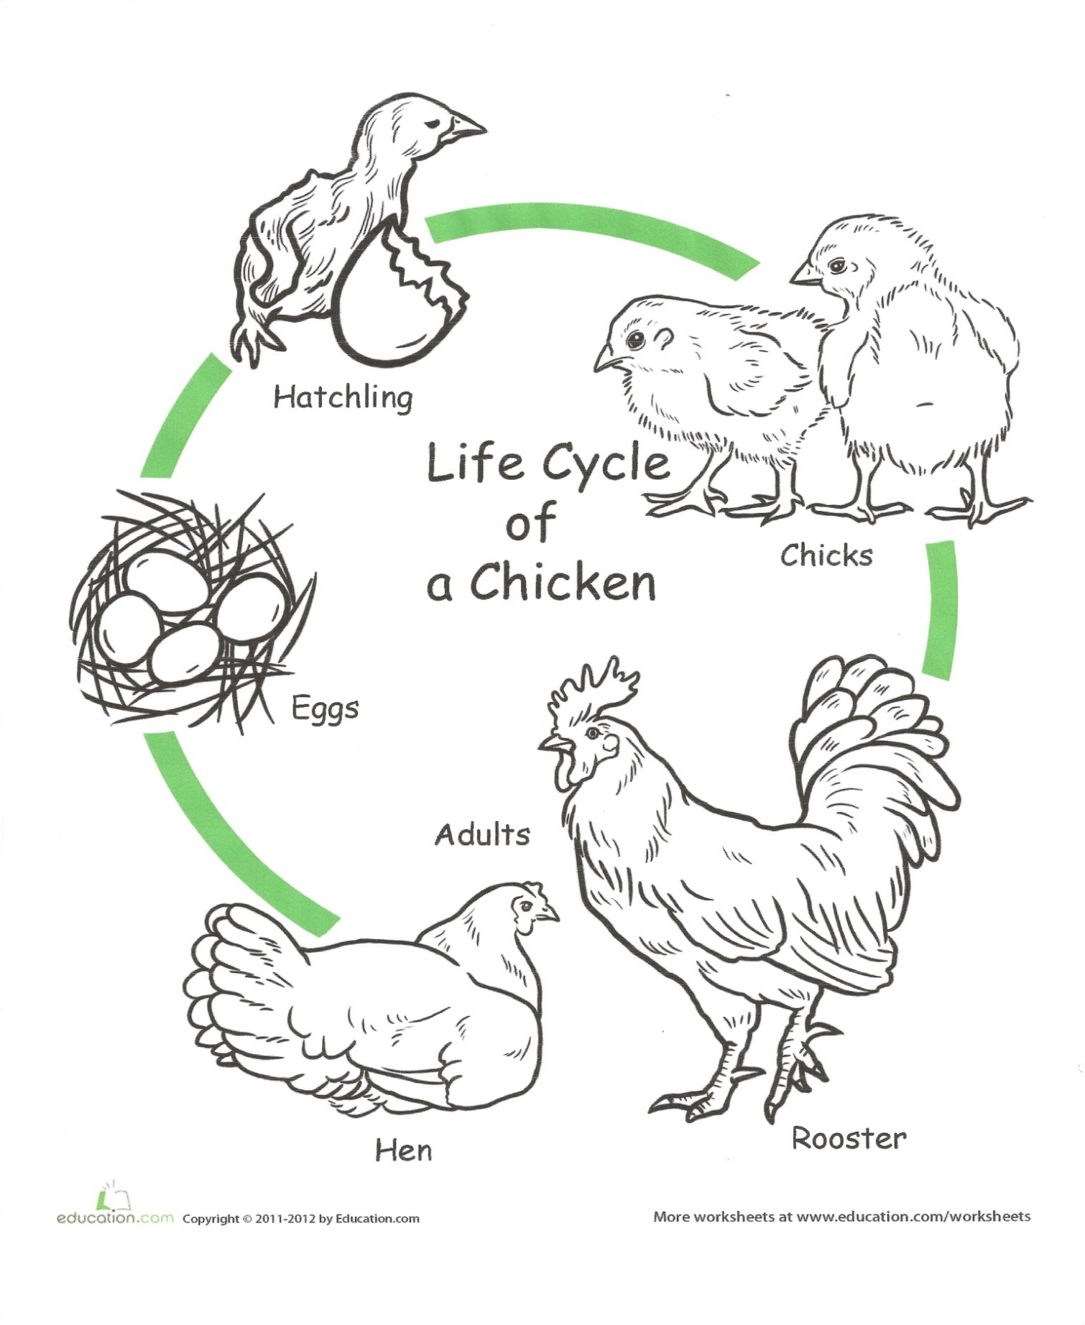

2025-JUNIOR MARKET POULTRY PAGE 12

Complete the page that goes with your project.
JUST FOR FUN
CONNECT THE NUMBERS 1-60 TO COMPLETE THE TURKEY.
THEN COLOR HIM HOWEVER YOU LIKE.

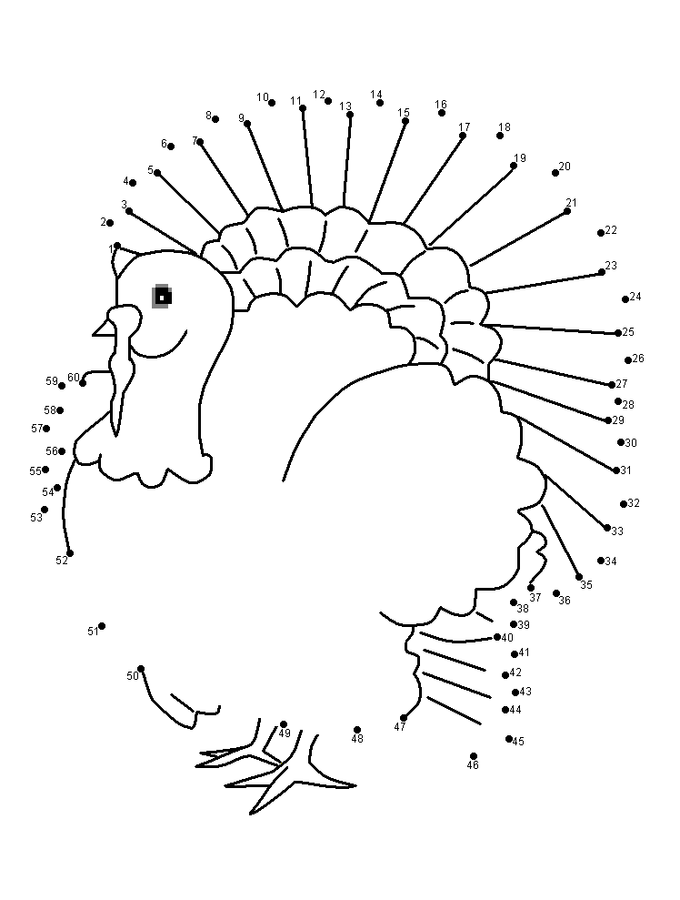

2025-JUNIOR MARKET POULTRY PAGE 13

Complete the page that goes with your project.
CONNECT THE DOTS AND COLOR THE DUCK

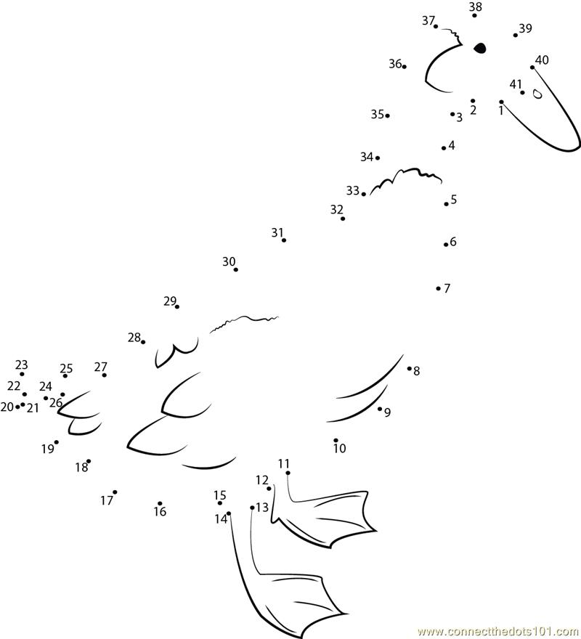

2025-JUNIOR MARKET POULTRY PAGE 14

Complete the page that goes with your project.

GOOSE COLORING PAGE

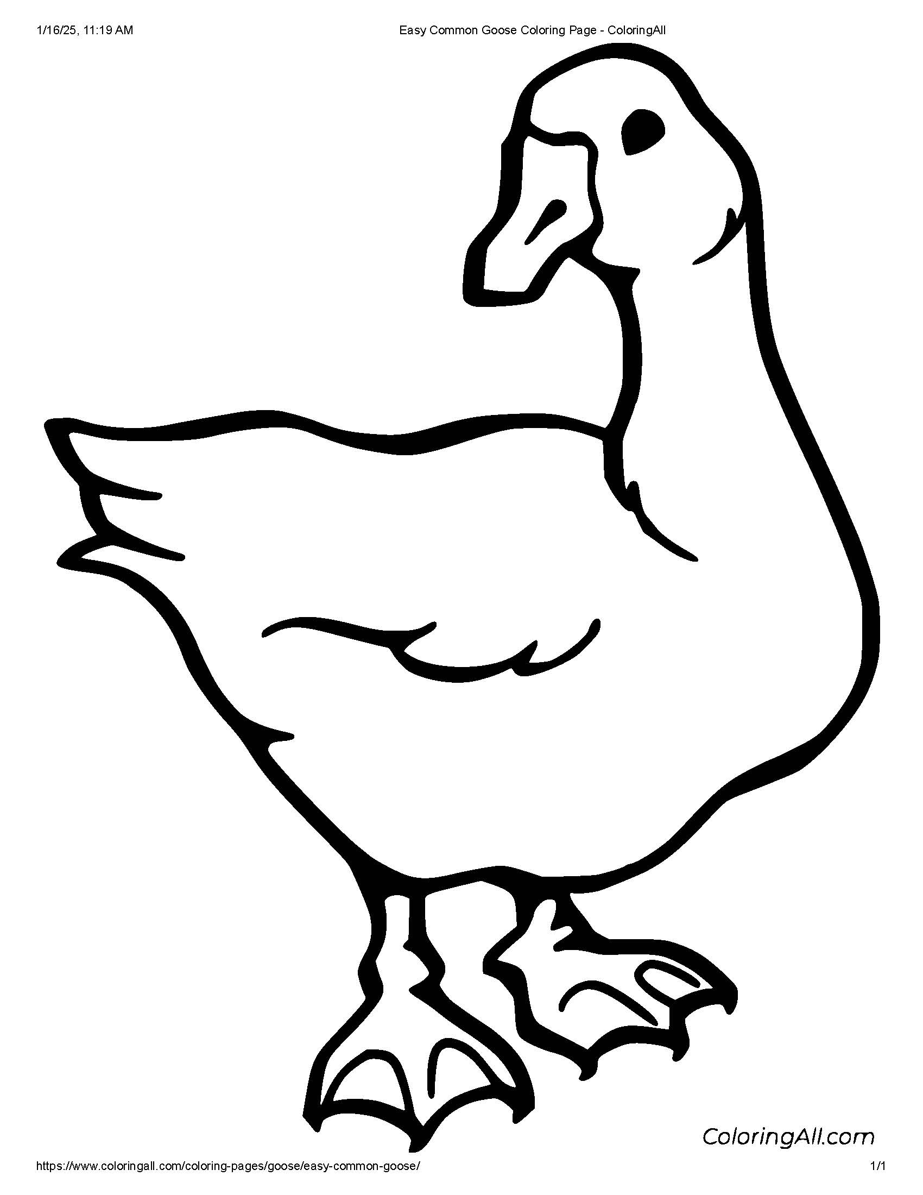

2025-JUNIOR MARKET POULTRY PAGE 15

MY STORY
(Interesting things that happened to me and my animal this year, challenges, highlights of my year or ANYTHING I would like to share about my overall
experience. You can even draw a picture of you and your animals if you prefer).

POTENTIAL BUYERS NAMES

As part of your Jr. Market Livestock Project, you must personally contact at least five potential buyers before the Oceana County Fair. You are encouraged to seek two new buyers that have not been asked or submitted before. You also must have at least three different buyers than those of your siblings in the market livestock project. Please confirm with your buyers their accurate mailing address (example: post office box vs. a street address). The information on page 14 must be completed and taken to the Oceana County MSU Extension Office on or before the due date where it will be copied and used to send out letters to your potential buyers. This page will remain in your notebooks. This is a Market Livestock Committee rule. Failure to comply will result in you not being able to sell your animal in the Jr. Market Livestock Sale.

2025-JUNIOR MARKET POULTRY PAGE 16
DATE: __________________
STAFF: __________________

JUNIOR MARKET/SMALL MARKET POTENTIAL BUYER’S LIST
POULTRY PROJECT (AGES 5-7)

Name______________________________ Club_________________________
Please print business names and complete addresses clearly.

  - Contact Name ____________________________________________________

Business Name ____________________________________________________

Mailing Address _________________________City_________________Zip_____

Phone _______________________ After Hours Phone______________________
Mailing Preference (Please Check One): Email ____ Postal Delivery ____

Email ____________________________________________________________

Signature__________________________________________________________

2. Contact Name ____________________________________________________

Business Name ____________________________________________________

Mailing Address _________________________City_________________Zip_____

Phone _______________________ After Hours Phone______________________
Mailing Preference (Please Check One): Email ____ Postal Delivery ____

Email ____________________________________________________________

Signature__________________________________________________________

3. Contact Name ____________________________________________________

Business Name ____________________________________________________

Mailing Address _________________________City_________________Zip_____

Phone _______________________ After Hours Phone______________________
Mailing Preference (Please Check One): Email ____ Postal Delivery ____

Email ____________________________________________________________

Signature__________________________________________________________
(Must be stamped by the MSU Extension Office)

2025-JUNIOR MARKET POULTRY PAGE 17

PICTURES OF YOUR PROJECT

(Please use this page for your project pictures. Add additional pages if you would like. The judges appreciate you labeling the pictures, so they know what the picture shows.)

NON-CLUB POINTS
4-H SMALL MARKET ANIMAL ASSOCIATION/JUNIOR MARKET PROJECT ATTENDANCE RECORD
(must be filled out by participant before requesting signatures from the office)
MEETING NAME | LOCATION | DATE | POINTS | SIGNATURE OF LEADER, SUPERINTENDENT OR MSU STAFF
Please note: This form must be included with your notebook and turned into the weigh master on entry day of the Fair. BEFORE SEEKING SIGNATURES AT MSU EXTENSION -MEETING NAME AND DATE MUST BE C OMPLETED. You need to accumulate nine (9) points to be allowed to sell your anima l. Six (6) of these nine (9) points must come from club meetings. Two (2) of these 9 points are non-club points must be earned from attending various 4-H events and activities. One (1) of these 9 points must be a fairgrounds workbee point. See your leader, the MSUE office, or online at http s: / /ww w .c a nrmsu .e d u/oceana / oceana county 4 h/ oceana 4 h market livestock for a listing of approved nonclub points.
CLUB POINTS
4-H SMALL MARKET ANIMAL ASSOCIATION/JUNIOR MARKET PROJECT ATTENDANCE RECORD

MEETING NAME | LOCATION | DATE | POINTS | SIGNATURE OF LEADER
Please note: This form must be included with your record notebook and turned into the weigh master on entry day of the Fair. BEFOFE SEEKING SIGNATURES AT MSU EXTENSION - MEETING NAME AND DATE MUST BE COMPLETED. You need to accumulate nine (9) points to be allowed to sell your animal. Six (6) of these nine (9) points must come from club meetings. Two (2) of the 9 points are non-club points and must be earned from attending various 4-H events and activities. One (l) of the 9 points must be a fairground workbee point.

